 statistical analysis to uncover trends, patterns, or anomalies within the laboratory test results. This could include:

* Time-series analysis to see how test results change over time.
* Cluster analysis to group similar patients based on their test results.
* Anomaly detection to identify outliers in the test results.

The time-series trend of Glucose (GLU) test results has been plotted:

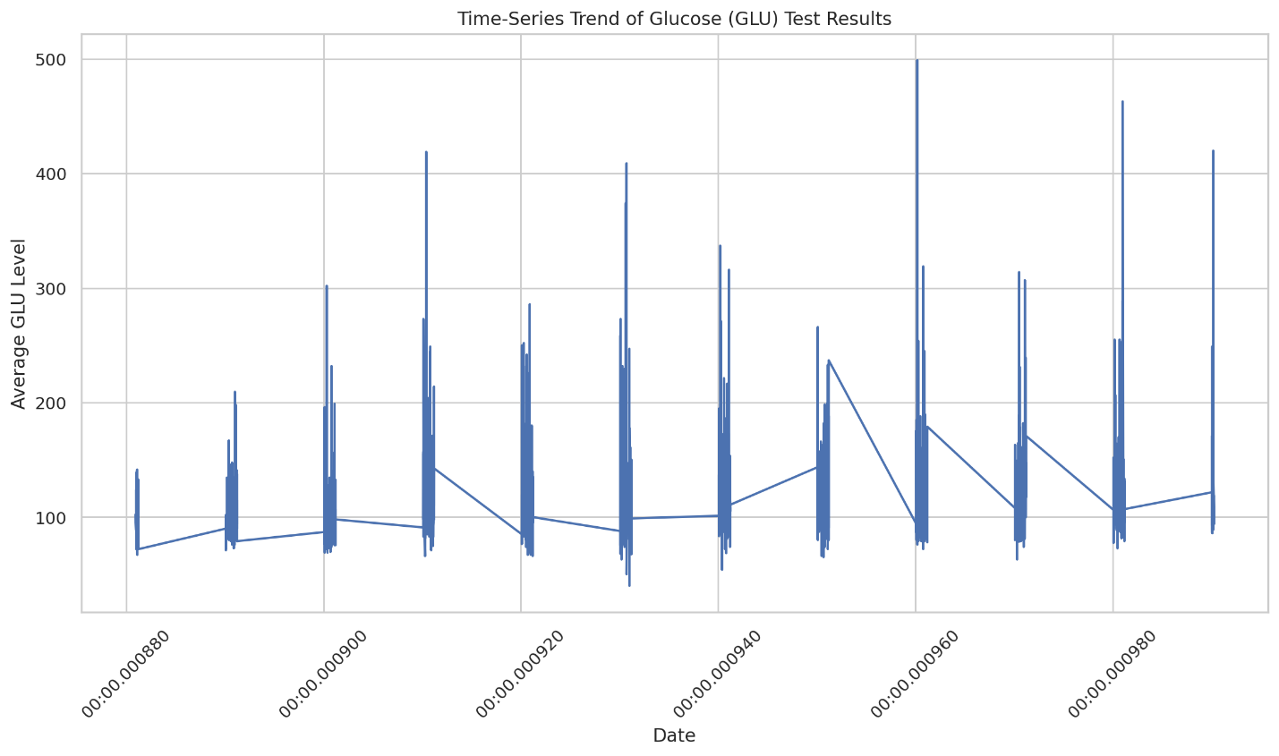

correlation matrix heatmap to identify any significant relationships between the key laboratory test results. This will help us see if there are any strong correlations between the tests.

correlation matrix heatmap for the key laboratory test results:

